**HUMAN COMPUTER INTERACTION**

**ASSIGNMENT NO. 2**

**Name: Muhammad Junaid Saleem Qadri**

**Enrollment no: 02-131202-057**

**Class: BSE-5B**

**[CLO1, PLO1]**

**Individual Assignment 04 MARKS**

Gestalt Principles are principles/laws of human perception that describe how humans group similar elements, recognize patterns and simplify complex images while perceiving objects.

Identify interface design or websites content which have used Gestalt principles (any 4) for organizing / structuring the website. Give snapshots and URL of the webpage (or its part) for each principle applied.

**Solution:**

1. **Similarity:** This principle suggests that similar elements should be grouped together in order to create a visual hierarchy. Sun microsystem and Airbnb's website Logo uses this principle to group similar properties together by displaying them with similar colors and shapes. In the below, you can see that all the properties in Paris are displayed with a similar color scheme and shape.

Source: <https://www.airbnb.com/s/Paris--France>



1. Timeline

   Description automatically generated**Continuity:** This principle suggests that the eye will naturally follow a path or direction. The Medium website uses this principle by creating a clear flow from one article to the next. In the below link, you can see that each article is displayed with a clear headline and image. The eye is naturally drawn to the headline, which creates a clear flow from one article to the next.

Source: <https://medium.com/>

1. **Closure:** This principle states that the brain will fill in missing information to create a complete image. Loaders are a common element in user interfaces today. Whenever a product needs a little more time to complete a task, like refreshing or processing a payment, loaders will let us know the product is still working in the background.

Khrystyna illustrates the principle of closure in her loader below. The moving, developing lines in the animation never really touch each other and yet we see a circle.



1. **Proximity:** This principle states that elements that are close together will be perceived as a group. In below image ,these groups don’t sit inside boxes or have clearly delineated borders around them. Yet we perceive them as separate clusters of content. We do so because the elements in each section sit close to each other.

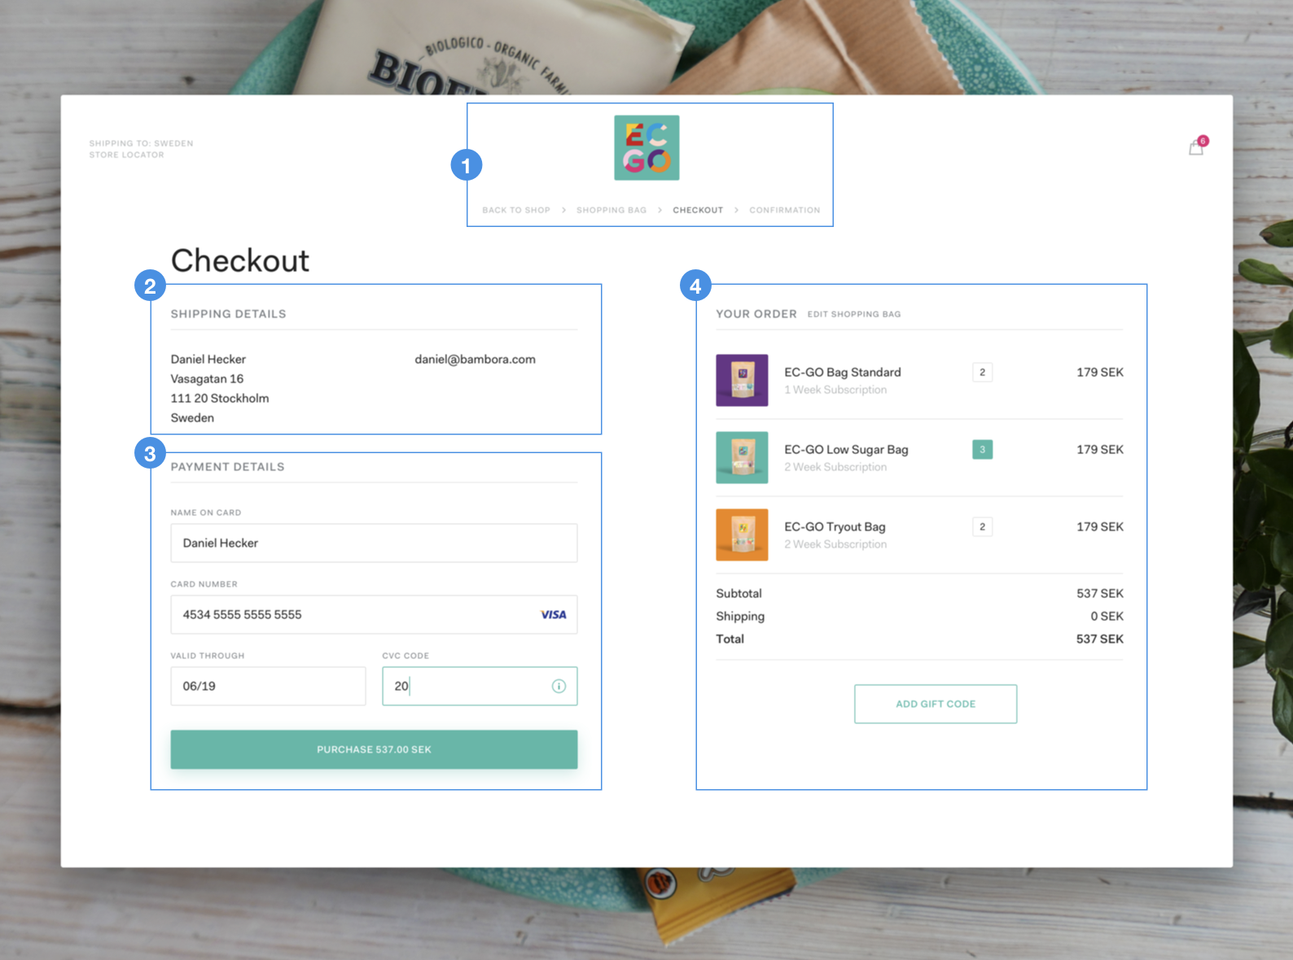

If you look a little closer, you’ll notice subgroups in each group. In group 3, each input field and label are perceived as a separate group. In group 4, each list item is perceived as another. This is the principle of proximity in action. Another great exammple are as below:

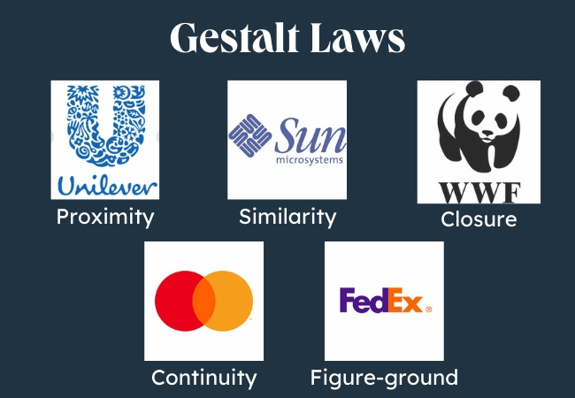

**-- The END --**